Receiving Store Automation System

Overview

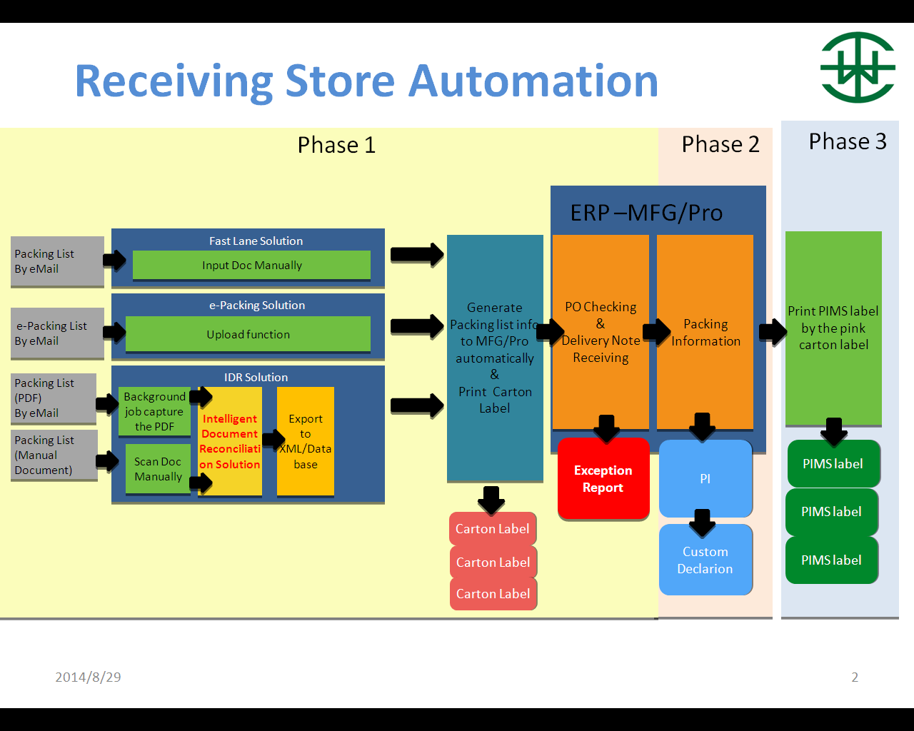

System Flow

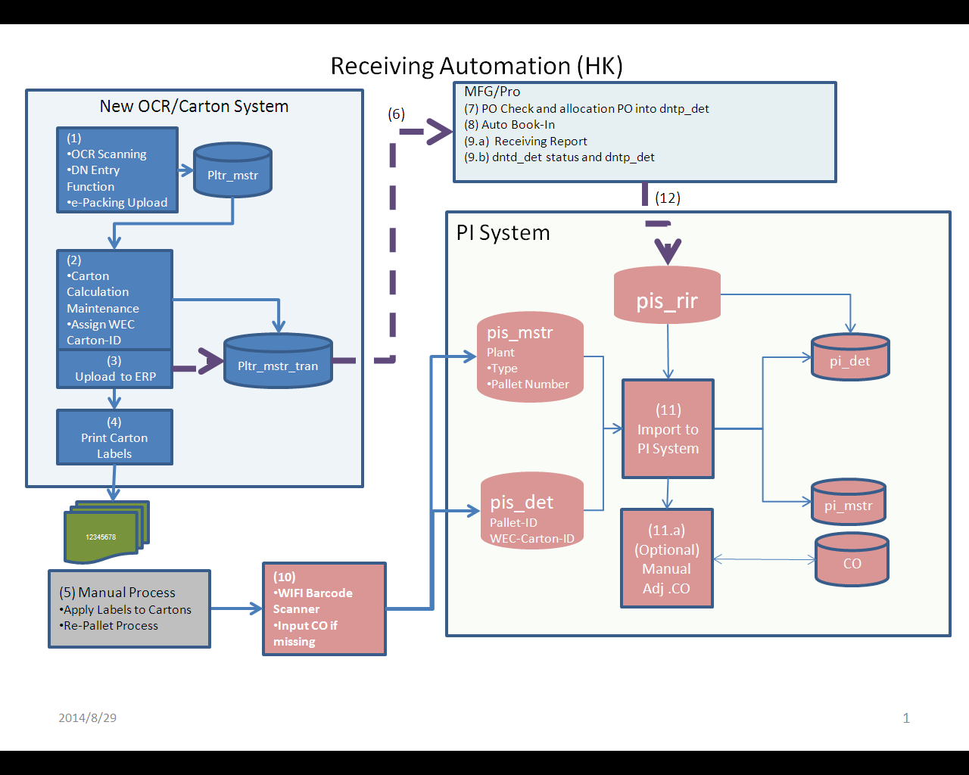

1. Information in DN/Packing List will be captured by either OCR, e-Packing List or Manual Input and stored in plr_mstr
2. Through calculation, carton information will be broken down into individual records. User can also make certain adjustment through maintenance functions. These records are stored in plr_mstr_trans. An unique WEC Carton ID will be assigned each supplier carton.

|  |  |  |  |
| --- | --- | --- | --- |
| Original Information |  | Supplier Carton Num | WEC Carton-ID |
| c1-10 | --> | C1 | 100000000045 |
|  |  | C2 | 100000000046 |
|  |  | C3 | 100000000047 |
|  |  | C4 | 100000000048 |
|  |  | C5 | 100000000049 |
|  |  | C6 | 100000000050 |
|  |  | C7 | 100000000051 |
|  |  | C8 | 100000000052 |
|  |  | C9 | 100000000053 |
|  |  | C10 | 100000000054 |

1. Records will be transferred to MFG/Pro (dntd_det & dnt_mstr) through WEB services after users’ confirmation
2. Print Carton labels will be print through Barcode Printer and the format is as follow

WEC Carton Label Sample

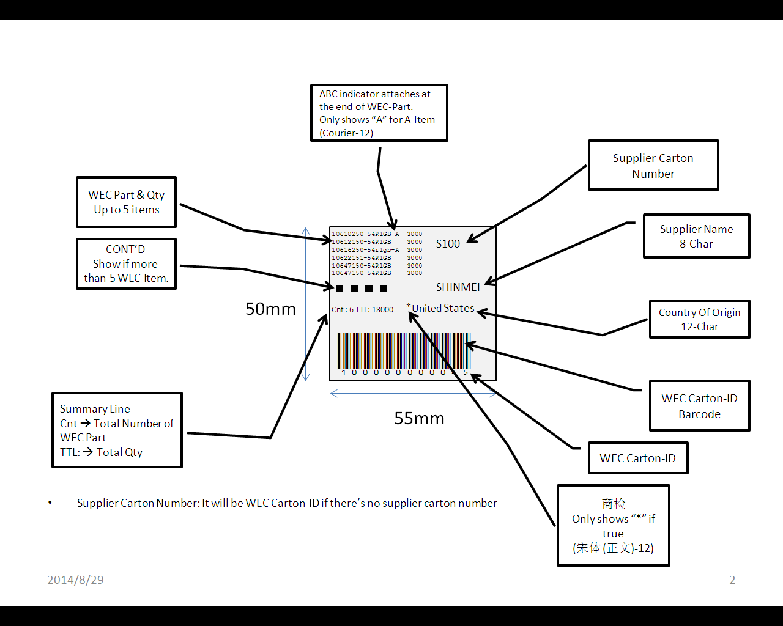

1. Receiving store applies labels to each carton
2. WEB Services transferring data to MFG/Pro

Step 7 , 8, 9a and 9b

**OCR Functions (in MFG/Pro)**

* Data from Supplier invoices and Packing-List will be captured through OCR.
* There will a schedule job to auto-transfer data to MFG/Pro
* A Unique Wong’s Carton ID will be assigned to every carton.

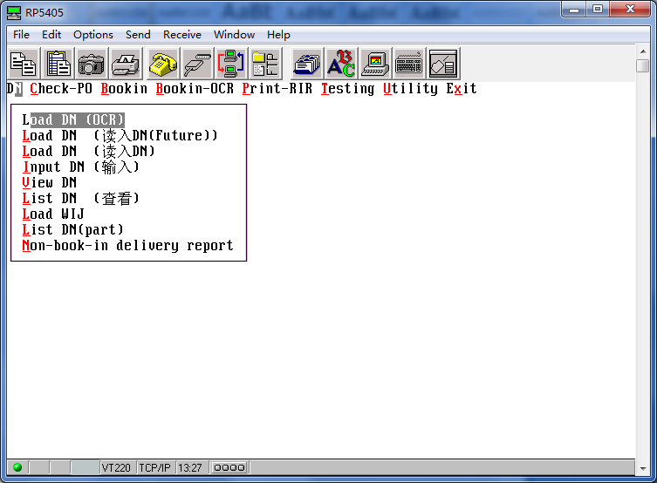

**Data in MFG/Pro**

In MFG/Pro, a unique Batch Number will be assigned to each supplier DN.

Status = ‘Start’.

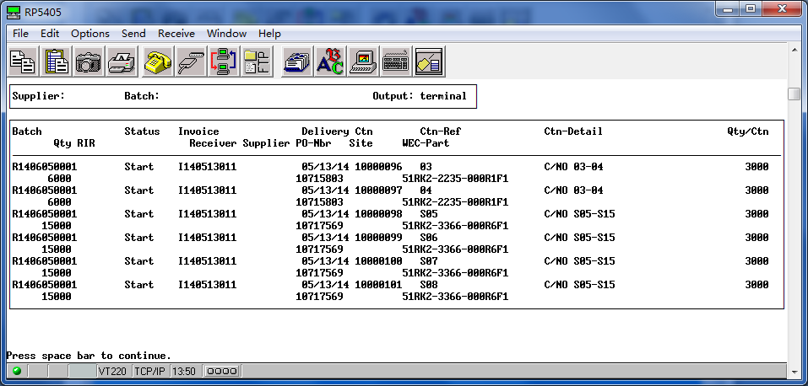

**PO Checking**

System will auto consolidate all cartons into corresponding PO Line for PO-Checking.

There will a scheduled job to performance Auto PO checking and an auto-mail alerts will be sent to notify corresponding PO Buyers if there any Problem PO such as:

* PO Not Approval
* To Early/Late for receiving
* Delivery does not match with Demand (for Bulky/Scheduled items only)
* Cancellation request from ACO
* Other Basic information validation
* Status = ‘Checked’

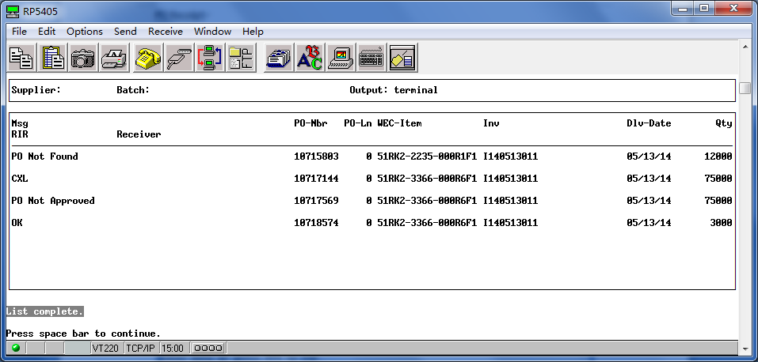

**PO Receipt**

When all PO lines within one Batch-ID are checked and are ready for Book-In, users can input the Batch-ID for Auto-PO-Receipt.

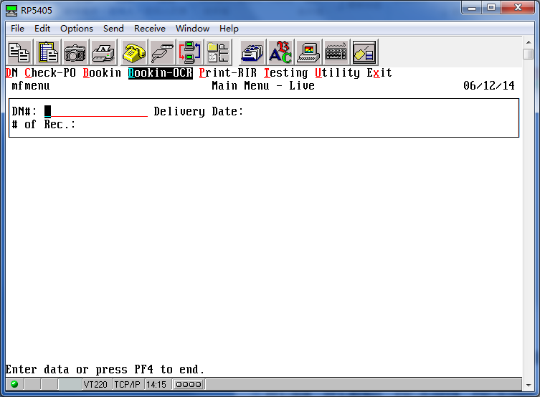

After Auto-PO Receipt is completed, Status = ‘End’. And corresponding RIR will be assigned to each Wong’s Carton ID:

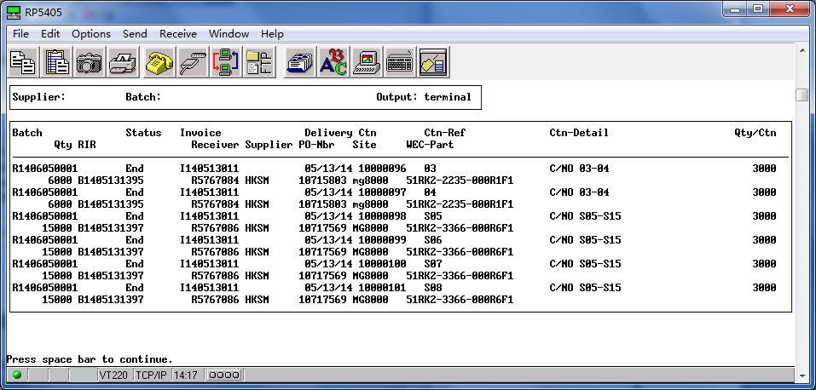

Integrate with PI System

Preparing PI Report

1. Step 10 Use Barcode Scanner to scan the WEC Carton-ID
2. Using Wec-Carton-ID as key, the related GRR records will download to temp-tables:
   1. Pis_mstr
   2. Pisd_det
   3. Pisr_grr

(Please refer to the Table definition at Table Section)

1. If CO (country origin) is missing , users can edit the data using the following function



TABLES

|  |  |  |  |  |
| --- | --- | --- | --- | --- |
|  | **pis_mstr** | **Label** | **Field-type** | **Value** |
| Unique | pis_batch_id | PI-Num | Char-50 |  |
|  | pis_plant | Plant | Char-8 | NW/Wellop/SZ |
|  | pis_type | Type | Char-8 | Normal/RMA/MECH |
|  | pis_sys_date | Sys-Date | Date |  |
|  | pis_time | Time | hh:mm:ss |  |
|  | pis_user_id | User-ID | Char-20 |  |
|  |  |  |  |  |
|  |  |  |  |  |
|  | **pisd_det** | **Label** | **Field-type** | **Value** |
| Unique | pisd_batch_id | PI-Num | Char-50 |  |
| pisd_plt | Pallet-Num | Char-10 |  |
| pisd_wec_id | WEC-Carton-ID | Char-12 |  |
|  | pisd_co | Country Of Origin | Char-50 | Map with co in PI system |
|  |  |  |  |  |
|  | **pisr_grr** | **Label** | **Field-type** | **Value** |
| Unique | pisr_batch_id | PI-Num | Char-50 |  |
| pisr_wec_id | WEC-Carton-ID | Char-12 | dntd_wec_id |
| pisr_plt | Pallet-Num | char-10 |  |
|  | pisr_rir | RIR # | Char-25 | Dntd_rir |
|  | pisr_invoice | Invoice | Char-40 | Dntd_inv |
|  | pisr_part | WEC-Part | Char-25 | dntd_part |
|  | Pisr_receiver | Receiver | Char-12 | Dntd_receiver |
|  | pisr_site | MG | Char-8 | dntd_site |
|  | pisr_po_nbr | PO-Number | char-15 | Dntd_po_nbr |
|  | pisr_qty | Qty | Decimal-0 | dntd_qty |
|  | pisr_curr | Curr | Char-5 | prh_curr |
|  | pisr_cost | U/P | Decimal-6 | prh_curr_amt |
|  | pisr_base_cost | U/P(Base) | Decimal-6 | prh_pur_cost |
|  | pisr_us_cost | U/P(USD) | Decimal-6 | Convert prh_pur_cost into USD |
|  | pisr_seq | Seq | Char-8 | pt_mstr.pt__qad23 |
|  | pisr_con_code | Custom Conn | Char-8 | pt_mstr.pt_draw |
|  | pisr_ch_desc | Description (中文） | Char-50 | sq_mstr.sq_name |
|  | pisr_net_wt | Net Weight | Decimal-6 | pt_net_wt |
|  | pisr_rec_type | STS/IQC/SI | Char-5 | STS or IQC or SI |
|  | pisr_abc | ABC | Char-5 | A or Blank (dtab) |
|  | pisr_code | **商检** | char-5 | * or Blank (tmp_tab) |
|  | pisr_lic_req | Lic. Req | char-8 | pt__chr05 |